2.9 Mt. Tabor

Mount Tabor, Mount Tavor (Heb), Jebel et Tor Jebel et Tur (Arabic).

Summary of the description of the Property and its history and development
New Testament reference
The Transfiguration: Matthew 17:1-8; Mark 9:2-10; Luke 9:28-36
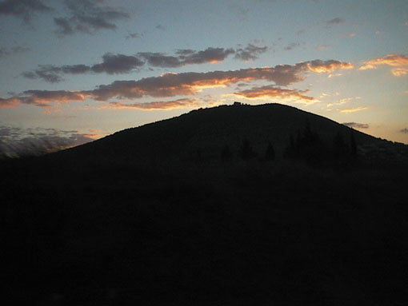

Fig.104 General View of Mount Tabor. Looking south

Significance
In the New Testament the Transfiguration of Jesus took place on the mountain that identifies (according ancient tradition) with Mount Tabor. The mountain is the place where Jesus reveals himself as the founder and leader of the community
This episode served to renew in Christians the hope of the Parousia, the Second Coming, anticipated return of jesus from Heaven to earth, an event to fulfill aspects of Messianic prophecy (Bottini 2004). It is probably that this tradition was worship since the very begging of Christianity and remains of sanctuaries appears already in the 4th century A.D associated with sources and pilgrim activities through all ages.
The splendor of Mt Tabor and its natural beauty probably hosted pagan worship til the Byzantine period, where, according ancient tradition, Jesus Christ transfigured in this holy place. It originates in the grace of the place. Jesus reveals himself as the founder and leader of the community and God spoke to him: "This is my Son, my beloved. Listen to him" (Mark 9, 2-10). This episode served to renew in Christians the hope of the Parousia, the Second Coming, anticipated return of Jesus from Heaven to earth, an event to fulfill aspects of Messianic. Christianity from its first steps embraced Mount Tabor and developed traditions, sanctuaries and churches and made it essential part of its pilgrimage.

Detailed description of the Property and its history and development
Mount Tabor, a uniquely rounded mountain at an altitude of about 1800 feet, rises softly in the yizrael Valley. On its summit there are two Compounds:
1. The Franciscan Compound encompass the Archaeological remains, the Franciscan Church
of the Transfiguration and the Monastery.
2. The Greek Orthodox Compound including the Greek Orthodox Church of the Transfiguration
and the Monastery.

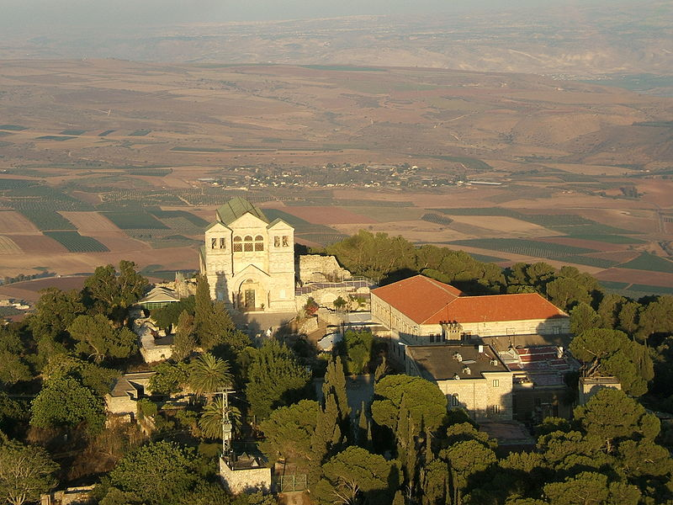
Fig.105 The Church of the transfiguration, looking east

Name and identification
Some scholar identify the name BRATHY of a mountain mentioned by Philvius of Biblos (c 64-140 AD) as alteration form of the THABYR . .In the the fourth century Eusebius from Casarea identify mount Tabor with the miracle of the Transfiguration (Ps LXXXVIII, 23, Pg. 23, col 1092 D.). and since it was unquestionable as it is approved by Origanus or Cyrilli from Jerusalem (XII, 16, P.G,33, col.743).

Description of Mount Tabor today
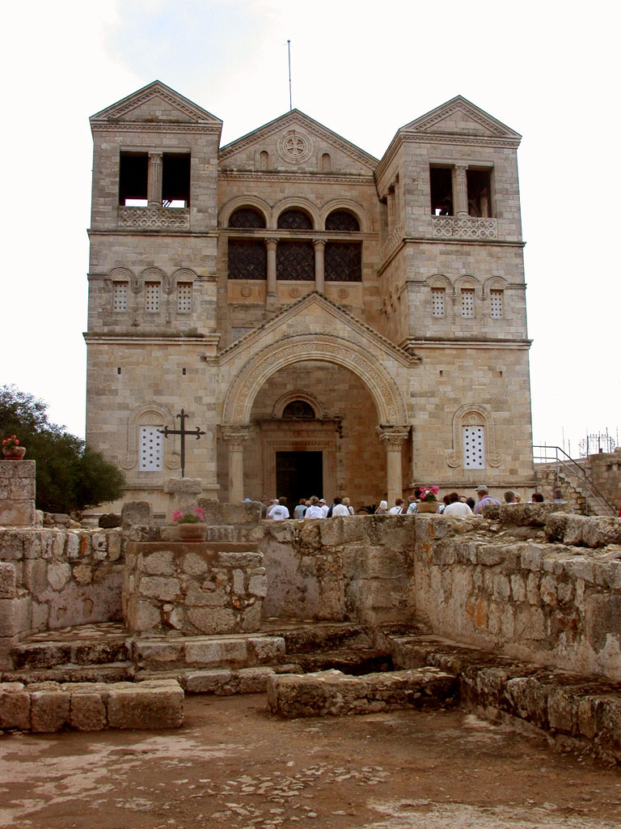
In 1870 the Father Custos of the Holy Land sent Fra Giuseppe Maria Baldi to take care of Tabor. He began by cleaning the cisterns and he gathered material for the future constructions. After three years he began to build a hall to receive the pilgrims, two rooms and a kitchen.
In 1875 the Franciscans thought to prepare an oratory in two spaces of the Saracen fortress and the first action was to demolish the wall that divided them. The various works were completed by the next year. To decorate the oratory the archduke Salvatore Luigi, brother to the Granduke of Toscany, sent a painting of the Transfiguration which is kept today in the sacristy of the basilica. In 1877 they began to build a tiny convent next to the hall and a Casa Nova (hotel) for the pilgrims, a liitle more to the west. In 1879 the first Franciscan community was established on Tabor; the little convent became a residence in 1888 and the first superior was Fr Alfonso Dombrowski.
In 1889 pilgrims from the United States, hoping to be able to rebuild the basilica, opened a campaign for donations, but the difficulties that arose were too great. At least the archaeological excavations in 1895-97 continued under the superior Fr Marcello Neuvillac and in 1897-1900 under the superior Fr Barnabas Meistermann. The dig showed the base of a Saracen tower (east) and other ruins of the Benedictine monastery (north). Among these latter one could see the chapter hall, the refectory and the kitchen. Fr Meistermann restored the Bab el-Haua, the gate of the wind, and, because of the property rights, placed the date 1868. In addition, he noticed toward the south of the plateau traces of houses as well as of grottoes, of sepulchers and of tombs carved in shafts, all of which had been violated. He judged that the houses and tombs were of poor people, probably from the time of Flavius Josephus, on which were built the dwellings for the workers in the time of el-Adel. Finally Fr Meistermann described the ruins of the basilica and sketched a plan of them. Substantially he thought that the crusader church was built exactly on top of the Roman-Byzantine church.
The crypt, which corresponded to the traditional site of the transfiguraton, would have been extended toward the west and would have constituted the venerated spot. Fr Meistermann noted down the columns of a portal (at the sides of “C” in his small plan) and concluded that in a second moment, probably during the truce of Frederick II, the side walls of the church had been extended toward the west. The two chapels so-called of Moses and Elijah, at first independent, would have been at that time incorporated into one single edifice.
In 1909 and years following, the great moat was cleaned out which protected the fortress of el-Adel on the eastern side. The work uncovered the mosaic floor and lower courses of the walls of a Byzantine baptistery. At the same time, due to crowds of pilgrims, the Casa Nova was enlarged and in 1912, Fr Roberto Razzoli, the Custos of the Holy Land, and the engineer, Giulio Barluzzi, brother to the architect Antonio Barluzzi, began studies for the erection of a new church. The Italian-Turkish war caused the suspension of activities and the World War I also directly affected Tabor. In April 1915 the Turkish governor of Nazareth ordered the closure of the little friary in which he left as guardian Fra Joseph Ege, a German. Four months later the Italian religious were deported to Damascus. During a visit to the mountain in August, 1915, General Jamal Pasha collected the diverse archaeological finds of value.
On October 21, 1919, on the occasion of the seventh centenary of the coming of St Francis to the Holy land, under the Custos of the Holy Land, Fr Ferdinando Diotallevi, the Cardinal Filippo Giustini, protector of the Order of Friars Minor and Pontifical Legate, laid the cornerstone of the basilica to be erected. In the same year, Fr Godfrey Schilling, Commissary of the Holy Land in Washington, DC., with the blessing of Pope Benedict XV, started a crusade to collect the necessary funds.
The direction of the work was entrusted to Antonio Barluzzi, author of the design. The architect tells us how he decided on a particular style: “The archaeological excavations brought to light an ancient crypt with a stairway down to it, walls of the apse from three periods super-imposed on each other with slight variations in the gradient [...] In the whole picture one could accentuate the design of a central crypt with a church above with three naves whose side walls relate to the facade of the chapel and the central one to the entrance vestibule. This arrangement, which fulfilled in a certain way the wish of St Peter to construct three tents [...] had a very touching comparison to the plan of some churches of the 5th c. near Aleppo, and near to that of St Simeon the Stylite. This fact would help one accept the suggestion of that rather unknown architecture, Roman-Syrian, which in its main characteristics was decadent classical with a slightly eastern decoration”
In 1920 the Department of Antiquities of the British Mandate government, fearful that the ancient stones would disappear, sent an inspector to examine the plans together with the engineer Liberato Traversa and Fr Antonio Gassi, guardian at Nazareth. He gave assurances that all the ruins would be respected. While the exca- vations were open, the engineer G. Barluzzi sketched a very precise plan in which the Roman and Crusader parts as well as the Arab structures stood out clearly.
The first work began in April, 1921; 20,000 cubic m. of garbage and fill was thrown down the southern side of the mountain and used to create and support terraces for farming. In order to facilitate the transport of materials and food for the 300 workers employed, the Custody of the Holy Land repaired 12 km of road from Afula to the foot of Tabor and substituted the old mule route to the summit with a road for automobiles. It seems that along this latter road there appeared some traces of the 4,340 steps mentioned by Epiphanius the Monk. The necessary water supply had to be obtained from the plain, as happened in the time of Flavius Josephus.
During his investigations the architect Barluzzi recognized that the cruciform sanctuary, of which various visitors had written, had been originally one of the Turkish baths of the fortress and he noticed some others. Moreover, under the northern wall of the so-called Elijah chapel, he found the tomb of a prelate. There was a body inside, which disin- tegrated on contact with the air, some ribbons of violet silk and a pectoral cross with a double crossbar. Due to the needs of the new construction, they walled up the tomb. One discovery of Barluzzi, which could have been sensational, was the grotto under the crypt.
At the moment of the discovery, the walls of the grotto were still covered by various and precise layers of plaster, which showed it had been a place of cult, with all probability a place of worship of the Jewish Christians. At that time the Jewish Christians were still practically unknown. No one thought of them nor did they examine the layers of plaster for any graffiti. Barluzzi simply thought the grotto was “a rocky space under the altar with an obscure purpose”. Unfortunately the walls of the cave showed serious cracks, perhaps provoked by the earthquakes and the roof threatened to cave in. Instead of strengthening it with pillars, the builders filled it partially with a pile of earth and stones.
The basilica was finished in the spring of 1924. We do not know whether it was a plan or a coincidence: the Custody of the Holy Land took on simul- taneously the construction of the church of the Transfiguration and that of the Agony of Gethsemani. The two edifices were blessed within fifteen days of each other. The link between the episode of the Lord’s glory and of his sorrow was confirmed likewise in stone.
For the ceremonies of the consecration Pius XI sent Cardinal Oreste Giorgi, the Major Penitentiary and protector of the Franciscan Order. On May 31, 1924 Cardinal Giorgi, who was accompanied by the Patriarch of Jerusalem Mons. Luigi Barlassina and by Onorato Carcaterra, OFM., titular bishop of Ipso, was received at the foot of the mountain by Fr Domenico Monaco, superior of Tabor, who met him with a cavalcade of 70 Beduins and Circassians.
The prelates left in the church the relics of the holy martyrs Clement, Urbanus, Lucius and Agatha. After the all night vigil over the relics, on June 1st, the cardinal entrusted the basilica to the promoter of the construction, Fr F Diotallevi, Custos of the Holy Land, and then he consecrated the altar of the central apse. At the same time the Patriarch consecrated the altar of the crypt, the bishop Carcaterra that of the south and Fr Diotallevi that of the north. Once the ceremonies of the altars were finished, Mons. Carcaterra celebrated the Mass. Also present were the Governor of Galilee, the military and civil governors of Nazareth, the Italian vice-consul of Haifa and the two Barluzzi brothers.
Fig.109 The Church of the Transfiguration, looking east

Starting at Daburiyeh, after 5 kms of hair-pin curves, you arrive at the Gate of the Winds, Bab el-Haua in Arabic, the main gate of the fortress of el-Adel, which originally was a double gate like a forceps. While there are only meager traces of the wall by Flavius Josephus, the ruins of the Saracen battlements, considerably preserved, circle the plateau on the summit.
On the outside of the gate there is a small road that leads to the grotto of Melchizedek on the property of the Greek Orthodox monks. According to Niceforus Callistus, St Helena on Tabor erected a church where Melchizedek had blessed Abraham (PG 146, 113).
There are rather conspicuous ruins that seem to have been a monastery and are found immediately to the east of the grotto. Ancient descriptions of this complex do not exist, which at one time could have been a coenobium but the remains must still be dated. In 1974 the grotto was restored and closed with an iron gate, the key to which is kept by the Greek Orthodox priest of St Elijah.

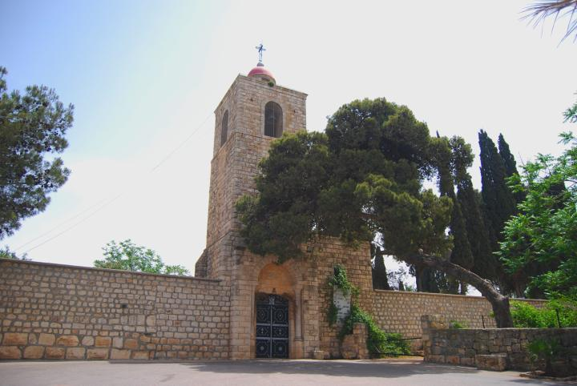
Fig.110 The Greek Orthodox Church of St Elijah, looking east

The church of St Elijah is found at the end of this little road. The sacred building with 3 naves, reconstructed after 1858, had been decorated in 1912 by a Greek artist named Socrates, who in the apse painted the scene of the Transfiguration and on the columns the figures of Moses, Elijah, the Evangelists and other biblical personages. In the two apses you can see the courses of ancient stones and, on the floor, six panels of white tesseras discovered on the surrounding property. Only two icons of those given by Russia and noted down by Guerin in 1863 as very beautiful still remain.
The apse identified by De Vogaa is visible from the outside of the building to the south. In the few stones remaining, that are plastered with white stucco as a means to keep thieves at bay, a small area opens up which was originally closed by a little window. This was where the sacred vessels were stored.
From the Gate of the Wind there is a straight corridor towards the east, flanked by leafy trees. After about 300 m you find on the south side the little chapel called Descendentibus (Latin for those who were descending). It recalls the command given by Jesus to his three disciples not to speak of the Transfiguration. For this chapel too we do not have ancient witnesses. It appears that in 1921-24 Byzantine ruins had been discovered and now are incorporated into the building constructed by Barluzzi who followed the ancient perimeter. The tiny area (9m x 4) was decorated for a certain period with a painting that reminded the visitor of the Gospel episode. Today it is empty. During the month of May sometimes Mass is celebrated. To the south you find the tombs of the 1st c. and to the north another monastery called Crusader.
Once you have passed this chapel, you begin to see the magnificent basilica of the Transfiguration. The line of trees continues and ends in a plaza, closed on the east by an iron chancel beyond which you see the remains of the Benedictine complex, the kitchen, the refectory, and a small chapel. To the north of this area, a corridor with arched doors and Crusader ruins left over during later periods still have to be studied. A dedication in marble, placed on the northern lintel of the chapel door, reminds one of the ancient tradition of the apparition of the Risen Lord (Mt 28: 16-17) and a bronze bust of Paul VI on the southern lintel recalls the visit by the pontiff. The chapter hall of the Benedictine monastery can be seen along the north side of the basilica.
Continuing to the north, outside the basilica, beyond the chapter hall and the remains of the stairs that lead up to the level of the Crusader buildings, you will arrive at a small stairway that descends on the steep eastern slope of the mountain. The road is really difficult but it continues to the place where there was a hermitage that the Saracens changed into guardpost. The same path leads to a narrow tunnel, opened for practical reasons for the construction of the basilica, and whatever remains of the grotto in that place was presumably a place of worship for the Jewish Christians.
Seen from the outside, the northern and southern walls of the basilica are extremely simple, while the eastern side has an interesting group of rocks and ruins. The two side apses in a straight line flank the central apse with its semi-circular shape and are decorated on high by two rows of small columns. Under the central apse there is the apse of the crypt which in turn rests partially on the remains of the fortress of el-Adel. The structure, which from the bottom of the crypt to the point of the tympanum measures almost 25 metres , is held up by pillars which go down into the Saracen wall to a depth of 10 metres.
The western side, the facade of the basilica, mirrors faithfully the Roman-Syrian style chosen by Barluzzi, a style which, because of the two towers in the front, allowed him to include in the body of the church the remains of the Byzantine-Crusader chapels.
The towers, although massive in appearance, are relieved by two rows of windows with alabaster glass and by a third row of open windows. Internal stairs lead up to two small choirs corresponding to the side naves of the church and to a larger central choir for the friars. On the top level of the southern tower are the bells, founded by Bassano del Grappa, that have a deep, harmonious sound.
The towers are connected on the western side by an arch of sculptured stone and their mass is united vertically to the facade itself. This middle section of the facade which like the towers ends in a tympanum is also made more gracious by three rather large windows. The bases of the towers and the facade mark off the external narthex and on its sides the Crusader stones are visible. There are three bronze doors that open on to the narthex, designed by Tonnini, with simple panels in them. The two side doors open into the ground floor of the towers. The central door opens into the church.
The southern chapel, dedicated to Elijah, is noteworthy above all for its Byzantine mosaic floor with white, black and red tesseras, which was restored once in the Crusader period and which has been taken up and recomposed partially in a new location. The curve of the apse is decorated with a painting that shows Elijah between the burning holocaust and a large piece of unburnt meat (cf I Kgs 18: 21-40). On the south side there is a Crusader funerary monument represented by an arch.
The northern chapel, dedicated to Moses, is a little more spacious than the other and has the modern mosaic floor a little more elevated than the other. Here too there is a painting in the curve of the apse: Moses, noble and persuasive, holds the tablets of the law in his left hand; behind him there is Sinai and on the sides a large burning bush and a rock with water flowing from it (cf Ex 17:6).
The interior of the church is divided into three rectangular naves with strong, large columns, linked by wide arches. The central nave covers on its western side one part of the Crusader crypt. The ancient stairway that goes down to it is protected by an iron grating in the floor near the church entrance. In the floor of the nave there are two glass windows to give light into the underground section. The central apse has two levels. The lower one, to which you descend by fourteen steps, includes the eastern part of the crypt. Here are conserved the courses of stones found from the Byzantine-Crusader apse; the altar is Crusader and the beginnings of the northern and southern walls of the crypt are also Crusader. The altar is dedicated to the three disciples who witnessed the Transfiguration. The floor of the crypt has been made of wood in order to preserve the original situation as fully as possible. There are two trap-doors in the floor: under the left one you can see the rock whereas under the right you see the inner part of the ancient grotto which has not been filled up.
On the upper level of the central apse there is the main altar dedicated to the Transfiguration.
The side naves are narrower than the central one and like it end in an elevated apse. In the north apseon the altar dedicated to the >Immaculate Virgin the Blessed Sacrament is kept. In the south apse the altar is consecrated to St Francis. The two bronze statues with the sanctuary lamps and the candlesticks are the work of Tonnini. A few stone steps connect the side naves to their apses above and these two link on the upper level with the central apse.
The ornamentation of the basilica is very simple. On the walls of the central nave there are two friezes, one of stone engraving that follows the line of the arches and the other in a straight line of mosaic under the windows. The side walls of the crypt are covered by mosaic panels with a recurring theme. In all of them three angels appear with aureolas, large wings and long, white tunics. The symbols used in the panels change the meaning of each picture. A child resting in a manger holds in his hands a globe surmounted by the cross: the Nativity, the descent of the Christ to become man. The chalice and the host: the Eucharist, the transformation of Christ into food and drink for human beings. The lamb: the blood of Christ poured out for the redemption of humankind. The open tomb: the Resurrection and the Ascension, the return of Christ to the eternal glory of the Father. On the roof of the crypt, a large rosette in the center which includes the so-called monogram of Constantine plus the letters "alfa" and "omega"; this is surmounted by a cross with rays of light.
In the curve of the apse on the upper level there is the scene of the Transfiguration. Against a background of gold the central figure of Jesus stands out with very white clothing. On one side there are Moses and Peter; on the other, Elijah and the other two apostles. Golden rays descend from the center. The mosaics and the paintings in the chapels are by Villani; the sculptures, such as the capitals, are by Piroli.
The lighting was planned in great detail. Three large windows over the door, nine windows above each side of the central nave, three on the northern side and one on the southern side of the lateral naves, seven small windows in the curve of the apse and the great stainedglass window in the crypt----all give a rose and golden hue to the sunlight entering the church. So much light predisposes the pilgrim to the reading of the Gospel of the Transfiguration, almost like a prologue. There was to be even more abundant light through the large, transparent marble slabs on the roof, placed above the trusses. Unfortunately it was necessary to cover the marble with metal sheets to protect the interior of the church from the infiltration of rainwater. A door in the southern wall of the church leads to the sacristy, probably the guesthouse of the Benedictines, and also to the Byzantine baptistery. The mosaic floor of the latter is considered a good example of art from the 5-6th c. and is composed of a central panel with white, red and gray tesseras that is surrounded by a double border of tesseras of the same colors plus yellow, in curved line motifs. To the right and left of the baptistery Avi Yonah noticed the remains of mosaic floors made with white and black tesseras. These also are Byzantine.
If you follow a corridor from the baptistery to the north, you arrive at the Crusader crypt. In the floor there are four holes and different pits in the stone, which lead some scholars to believe they are the remains of a place of Canaanite worship.
To the south of the baptistery you can find the platform of the Saracen fortress where the defense weapons were installed. As regards the archaeological findings, Gu'erin noticed that among the rubbish that covered the church and crypt they had found different large pieces of marble columns; some ruined capitals, of which one was ornamented with small lions and another with the head of a ram; a stone with a Greek cross between 2 "alfas" and 2 "omegas"; an infinity of mosaic tesseras, some of glass and others of red, white and black stone; terra-cotta lamps and fragments of glas vials. On one broken piece of marble, there remained the Greek letters: ETAM KMXPI. Fr Meistermann found many small pillars of white marble, measuring 20 cm on the side, sculptured on two sides and with grooves on the other two sides, as well as pieces of panels of exquisite marble. Such evidence makes one think that the holy place was surrounded by besides the metal grating, also by a communion rail similar to that at Jacob's Well in the Byzantine and Crusader periods.
Fr Gassi described various capitals and pieces of capitals, some of marble, others of stone. He thought the small pillars of the chancel screen would be no later than the 6th c; they therefore would have been in the church seen by the Anonymous Pilgrim of Piacenza in 570 AD. Enlart thought especially intriguing the pieces of a frieze which must have been part of a great cornice, engraved with right angles entering and leaving the design. Since this pattern is common to the Byzantines and the Crusaders, its dating is uncertain. As regards the capitals, Enlart judged beautiful only those fragments of the Crusader period that maintained their coloring: "Romanesque art has not produced anything more perfect. These capitals must come from the portal with six little columns of the church of the Most Holy Savior." Enlart designed, after studying the considerable ruins, the crown for an edicule which perhaps was on the inside of the Crusader apse behind the altar.
In the Tabor Museum there are the following items:
* little metal utensils; arrow-heads, small bracelets, rings and metal crosses;
* fragments of glass and ceramic bowls; earthenware pots and various recipients; ceramic lamps, some glazed with yellow and brown;
* small borders of mosaic with various, colored tesseras;
* various capitals and bases of columns; fragments of small columns, of little pillars for the communion rail grooved on two sides, and of friezes;
* a collection of coins that are Roman, Byzantine and Byzantine with Arab, Ommayad and Mameluke markings;
* various Arab inscriptions from the time of el-Adel (originals and tracings) that are entire or in fragments;
* a hyena embalmed, the only sample of all the ferocious beasts of the past.
To the south of the plaza you will find the old Casa Nova, now recently modernized, a small clock tower and the entrance to the modern dining hall. This hall on its southern side has two large stained-glass windows. It opens out onto a terrace. From this point you can enjoy one of the more beautiful panoramas of Galilee, if not absolutely the most beautiful: the valley of Yizrael.
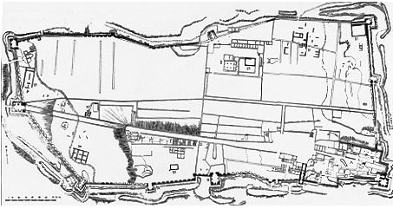
Fig.111 General map of archaeological remains

Outline of the Archaeological Research at Mount Tabor
Recent information though confirm the existence of a doric hellenistic temple on the mountain (Alliata 1992). Remains of fortification recorded from the Roman period on the summit apparently are those recorded by Josephus Flavius (Gal 1998).
The IAA survey exposed two Winepress hewn in the rock, ancient quarries. Remains of rectangular Crusader fortress and some more structures including remains of a Church from the 12 th century (Ibid) .
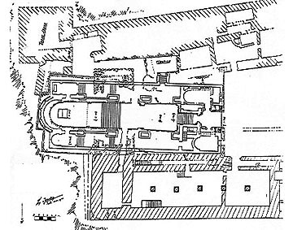

Fig.112 Plan of the Excavations
The Franciscans after 1854 - exploration
The first discoveries were made by Melchior De Vogu'e, a pioneer of Palestinian archaeology. He climbed Tabor precisely in 1854 and with his trained eye noticed among the stones and oak trees the remains of two sacred buildings. One, on the property of the Greek Orthodox was all that remained of a small chapel four meters wide and at the maximum five or six long, with a semi-circular apse to the east. The Roman walls, constructed with great care, were covered on the inside with white stucco on which they painted decorations of red grapevines. The mosaic floor had large white and black tesserae which formed a great circle with some square-shaped decorations. De Vog"u'e saw in the ruins an oratory of the 4th-5th c. and did not hesitate to consider it as one of the most ancient religious buildings in the Holy Land.
The other ruins, on the Franciscan property, belonged to a construction composed of some small underground spaces, with a vaulted roof, to which you climbed on a stone staircase. According to De Vog"u'e it was the ruined crypt of a crusader church which must have had three naves and three chapels. The scholar dated it in the beginning of the 12th c. De Vog"u'e based himself on what he saw; the excavations that followed resulted in a greater, but not absolute, precision and the opinions of the experts were varied.
On August 6, 1858 the Latin community of Nazareth, having climbed Tabor with the friars for the feast of the Transfiguration, decided to construct a chapel and two or three rooms for the religious. The work began the following day in a place that was a stone's throw to the north of the famous oratory. While digging to lay the foundations, the workers discovered three areas, one of which had a divano or reception room according to the Arab custom, and another which was larger (9,5 m x 4,75) with a well-preserved roof. They also found a place where five pillars rose up and were surmounted by arches. The work was interrupted by an epidemic but was taken up again the following spring. Fr Angelo Veneziani, the guardian of Nazareth, had discovered an extraordinary helper in Luis Kalil, the interpreter for the friary in Nazareth, who began to restore the three uncovered spaces. Due to other difficulties, the work had to be stopped again
In the meantime financial help arrived. One donation came from Canon Strauss, the president of the Society of the Holy Sepulcher in Cologne, Germany and another arrived from a countess in Vienna. The superiors sent some lay brother workers to build a wall around the Franciscan property and to continue the repairs of the ancient areas. The structures, which belonged to the Benedictine monastery, were demolished in 1921-22 because they obscured the view from afar of the new basilica for the pilgrims.
At the same time the works of excavation had freed at least partially the primitive church of the Transfiguration and all of a crusader chapel. Having obtained the authorization of the Patriarchate to erect a new sanctuary, Fr Barnabas of Appignano, guardian of Nazareth, intended to restore the church. The idea was set aside due to the opinion by Gu'erin, a French priest who was also an explorer and archaeologist. He had counseled the friars "to preserve intact and in full view, when they would execute this project, all those parts that still exist of the ancient church, and above all to maintain the primitive character of the apse as a sign of its antiquity and consequently of the antiquity of the tradition relative to the true place of the Transfiguration". The position of the apse was truly important. The great difficulties that the architects of the primitive church and of the successive churches had to resolve in order to put the large cross exactly in that spot, fabricated from lead and on the eastern side of the mountain, and the fact that the floor followed the difficult contour of the land, showed clearly their intention to place the apse on the venerated spot.
To Gu'erin we are indebted for a good description of the ruins. The Greek Orthodox had discovered a second and larger apse immediately to the north of the ruins noted by De Vog"u'e. Therefore the result was that these ruins did not belong to an independent oratory but were another nave of a three nave church, the ancient church of St Elijah. The Greek Orthodox had built a new sanctuary, 24 metres long by 15 wide, but it did not obey the primitive design.
The second construction noticed by De Vog"u'e also had a more complex reality: it was a church with three naves, 36metres long and at least 16 wide. Under the central nave there was a crypt, 30metres long by 6 wide, to which you descended by 12 steps, partially cut into the rock. In the eastern extremity of the crypt there was an altar half in ruins. The buildings above, according to Gu'erin, had been demolished and rebuilt several times but the crypt, partially carved out of the rock itself and in part constructed with very uniform stones, must have belonged to the sanctuary dedicated to the holy Savior in the first centuries of the Church.In the central apse there were the lower courses of the wall which Gu'erin judged to be Roman-Byzantine; beside the entrance (south side) you could see a chapel with a mosaic floor of multi-colored tesserae and a grave cut into the rock and surmounted by a crusader arch. At the moment of the discovery, the tomb held human remains.
This chapel was later confused by some authors with the ruins which De Vog"u'e had called an oratory. The problem could have been caused by the similar dimensions of the two small edifices, although the mosaic floors were different.
About twenty metres to the west of the entrance there was revealed another small chapel of crusader structure. Both the church and the chapel were found within the area of the large Benedictine monastery.
On the Saracen fortress Gu'erin noted impressive ruins of towers and connecting walls and portals with pointed arches. The stones were either completely smooth or with bosses.
The history of settlement at Mount Tabor
The Franciscans from 1631 to 1854
In 1632 Roger with the support of Fakhr ed-Din traced a plan of the existing sacred buildings adding a description:"There are three small oratories or chapels with vaulted roofs, each one next to the other, two of which are nine feet in length and three or four in width. The central one where Jesus was transfigured is only seven paces long. These tabernacles or chapels are found on the highest part of the mountain, on the southern side."
The Chronicles of Fr Verniero, written in 1634, refer to the intentions of the Franciscans, then owners of Tabor: "they thought they would bring `our Catholics from Bethlehem to dwell there and cultivate it' and they planned to build `a hotel for the convenience of our pilgrims'. Nevertheless `because they were unsure of the Arabs nearby, they built neither a church nor a hotel.
Actually the Muslims were hostile. Surius in 1644 reports in detail: "It was very sad for us to see these three tabernacles, which still exist through divine providence, because the Moors had blocked the entrance to impede the devotion of the pilgrims. Even so we took away enough earth so we could enter. We squeezed in through a small door to the north and we arrived in a corridor that was twelve paces long and four wide, where we lit the fire with a piece of iron on which a stone made sparks and,while each one held his candle, we passed through a northern door into the three tabernacles, in a great vaulted chapel which had been painted in the past. The chapel towards the east is seven feet and three fingers wide, that one towards the north is five feet wide and the third towards the west is six and a half feet wide.The central one is built on the spot where our Lord was transfigured". We believe that Surius was the last pilgrim to notice the decorations of the crusader crypt.
Ricoldo of Monte Croce would have wept to see, as Doubdan saw in 1652, "almost everything buried in fill and full of garbage". Doubdan also made a sketch and a description of the sanctuary:"You enter into a small corridor composed of four niches in the form of a cross, each one about four feet wide {...} The whole place now is completely buried and so dark that you must carry a light". Neither the sketch nor the description agree with the preceding information: the three tabernacles "honeycombed together" have become an empty space in the form of a cross.The entrance of the real sanctuary, blocked up, had been lost from view probably due to the vegetation covering it. The unknowing pilgrims, having found another way, followed it and arrived in one of the rooms of the saracen fortress, where pious hands had set up some altars. This place was the goal of their visits until 1876.
Besson knew how to see something important also in the divinely favored chapel: "I had the good fortune to say Mass on the altar of St Elijah, who still lives after so many centuries and who was sanctified before he died. His tabernacle is to the left of the entrance and on the right is that of Moses and in the middle, that of Jesus, as the center to whom all lines converge and the fulfillment of all the laws ".
From year to year the Saracen section also deteriorates more and more. In Nau (1668) we read: "Today there remains only one buried chapel where you enter by three doors that do not close [...]it is no longer than nine or ten feet and seven or eight wide. Three niches have been built where it is believed that our Lord, Moses and Elijah stood [...] According to the placement of the tabernacles our Lord had his face turned to the north, Moses stood on his right and Elijah on his left".
Laffi (1679) and Le Bruyn (1681) called the chapel "a grotto". Le Bruyn, while those with him celebrated Mass, sat in front of the door and sketched the ruins as seen from outside. The witnesses continue but are sad and depressing. In 1710 Cozza saw that the Franciscans used portable altars for their celebrations. Pococke (1737) added an interesting detail to his description of the grotto:"On the other side, there is a monastery of the order of St Basil, where the Greeks have an altar and celebrate their divine liturgy on the feast of the Transfiguration." It is the ancient monastery abandoned by the Greeks in 1187 which as Mariti will tell in 1760 was still called St Elijah.
The Franciscans had become the owners on Tabor 136 years before and had tried in different ways to make their rights prevail. Soon after the concession to the friars, Fr Diego of San Severino ordered Fr Giacomo of Vandame, guardian of Nazareth, to build a church on the mountain but the Muslims of the area opposed the project. Four years after the death of Fakhr ed-Din, the Franciscans asked the Sultan for permission to reside on Tabor and obtained it in 1641 through the ambassadors of France and of Venice. In 1656 the friars received authorization to construct on all their properties in the Holy Land. When the matter was referred to the Sultan in 1667 that the religious could not use their authorization on Tabor, the Sultan ordered the pasha of Safed to punish those opposed to it. Six years later, Fr Claudio of Laude Pompeia, Custos of the Holy Land, by means of Fr G.B. of Lagomarsino, Commissary of the Holy Land in Constantinople, asked permission to send two or three friars to live on the mountain. The request was to no avail. In 1763 the Custos of the Holy Land, Fr Paolo of Piacenza, seeing how impossible it was to fulfill the dream of a new construction, decided to repair at least what existed.
The restorations under the supervision of Fr Giovanni Lorenzo, the guardian at Nazareth, were modest enough. In a pilgrimage of 1771 Giuseppe Antonio of Milan left in writing: "On the upper part [of Tabor], a little towards its western side and almost in the middle, there rises a chapel amidst great ruins. It is five paces long and two wide, its front looks to the south; there is a poor altar [...] besides, there is to one side a small square passage with three niches, and these recall the words of Peter to his divine Master: "Let us make three tents." Lamartine said nary a word about this chapel. Other writers preferred to talk about the stupendous natural scenery, like De G'eramb, who confessed his sins at the foot of a tree and had the good luck to receive Communion during Mass celebrated under the open sky.
While the hostility of the Muslims against the friars lost some of its ferocity and the friars exercised at least their right to the property with the pilgrimages and celebrations, other difficulties appeared. The Greek Orthodox soon occupied the northern part of the summit, which finally was cut in two by a wall. The Latin Patriarchate of Jerusalem did not show much understanding and denied permission to build. In the first case the Franciscans out of love for peace tolerated the situation; in the second case, the friars appealed to Rome and the Congregation of the Propaganda in due time decided in their favour.
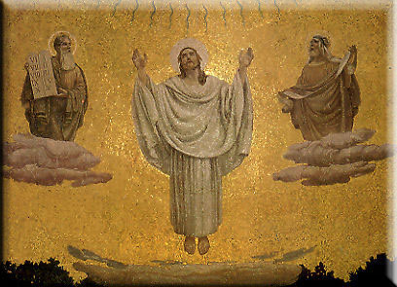

Fig.113 The apse of the Transfiguration Church, Christ in Glory

History and Development
In 1925 Mallon discovered on the western flank some fragments of instruments that could be dated to the first Paleolithic period. In 1964 Stockton found man-made flints and decided that almost all of them came from the middle Paleolithic period (about 70,000-40,000 BC) and from the upper Paleolithic (about 35,000 - 15,000 BC). The upper caves, still natural in part and in part worked by human hands and the absolute lack of water-springs led to the conclusion that the caves had not been inhabited however, the pre-historic man usually sought out his material on this mount. This very remote reach of antiquity was followed by a very long silence both in archaeology and in the literature.
Tabor in the Old Testament
The book of Joshua places sixteen cities in the territory of Issachar and specifies that the frontier "touched Tabor" (Js 19: 17-22). Moreover it says that the lands assigned to Zebulun reached the edge of Dobrath (Js 19:12), today called Daburiyeh or Khirbet Dabura respectively to the west and north of the mountain, while the lands of Naphtali reached up to Aznot Tabor (Js 19:34), which according to research lies probably to the east. Tabor then was right at the point of convergence of the boundaries of the three tribes.
In the episode of Deborah (Jg 4 & 5), which happened around Mount Tabor, it is probably that the cult of Yahweh has already been set up on the mountain. Deborah commanded Barak to gather his troops on Tabor (Jg 4:6) : this movement must not have been dictated so much by strategy as by the wish to pray to the true God in view of the coming battle against the invaders.
Tabor appears later in the episode of: on the mountain the leaders of the Madianites killed the brothers of Gideon (Jg 8:18 ). The Levitical cities are listed: “The rest of the Merarites received from the tribe of Zebulun: Rimmon with its pasture lands, and Tabor with its pasture lands (I Chr 6:62).
Tabor appears later in Hosea, the prophet who ministered in the second half of the 8th c.BC in the kingdom of Israel. After Deborah’s time the idol of the mountain must have been restored to honor because the tribes of the north continued to practice a syncretistic worship.
This cult had become official under Jeroboam I, the first king of Israel (930-910 BC), with the erection of the images to the bulls in Bethel and Dan. Achab (874-853 BC) also constructed a temple dedicated to the god Baal, in Samaria, at that time the capital of his kingdom. Later Elijah had killed off the idolatrous priests (I Kgs 18: 40) and Jehu in addition destroyed the temple in Samaria (II Kgs 10:25-27). Moreover these actions had no lasting effect and so Hosea declared firmly: “Then will I remove from her mouth the names of the Baals, so that they shall no longer be invoked” (2: 19) and he denounced the priests and princes for their responsibility in the matter: “Hear this, O priests, pay attention, O house of Israel, O household of the king, give ear! It is you who are called to judgment. For you have become a snare at Mizpah, and a net spread over Tabor” (5:1).
We find Tabor later in another prophet, Jeremiah, who considers it, together with Mt Carmel, as a symbol of preeminence. In the prophecies against the nations Jeremiah actually emphasizes the superiority of Nebuchadnezzar and compares him to the two mountains: “Like Tabor among the mountains he shall come, like Carmel above the sea” (48:18). In the Old Testament Tabor is mentioned for the last time in Psalm 89, which is full of celebration of God’s faithfulness: “Tabor and Hermon rejoice at your name” (v. 13)
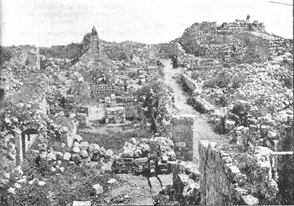
Historical Sources attest that in the Roman and Byzantine periods the majority of settlement in the area were Jewish villages. The fortification erected on Mount Tabor by Josephus Flavius on the eve of the Great revolt should be understood in that context (Flavius 1, 10, 8, 7).

Fig. 107 Remain of Byzantine church, looking east
The Roman-Byzantine period
After period of wars came a time of peace during which monasteries and churches in memory of the Transfiguration were constructed. The literary sources are quite rich in information. The book, S.Helenae et Constantini Vita, a document come down to us from the 11-12th c., but probably written about the middle of the 7th c., mentions that St. Helena climbed Tabor and that after she searched for and discovered where the Transfiguration happened, built a church there in honor of the Savior and his three apostles. The information was repeated by Nicephorus Callistus (PG 146, 113). We can find an indirect confirmation in Epiphanius the Monk: although he does not mention the construction by St. Helena, he described a stairway with 4,340 steps which started down in the valley up to the top of the mountain (PG 120,272). Epiphanius---the first author in Greek who, according to his writings, composed a report on the Holy Places---wrote in 750-800 and based himself on earlier documents and probably wrote the truth. On the Mount of Olives there was also a stairway of 800 steps, considered a work of Constantine, that started in the Kidron valley and climbed to the place of the Lord's Ascension (PEQ, 1896).
In the beginning of the 6th c. there already existed a diocese of Tabor. In the Jerusalem Synod of 518 a bishop signed in Greek written with Latin letters. This signature was illegible for the copyists of the acta of the council and was left aside or only partially copied, so that the name of the diocese became lost. In 1940 Schwartz finally deciphered the signature: Prestutus episcopos tu agiu orus Thabor, Prestutus bishop of the holy mountain of Tabor. As a result the diocese of Tabor was one of the most ancient of the valley of Yizrael.
It could be that the Constantinian church had been demolished to make way for the cathedral and the two chapels. The Anonymous Pilgrim of Piacenza (570) saw three sacred buildings and a century later Arculf (1898). spoke of a great monastery with three churches and many cells inhabited by monks. Besides on the top of Tabor, religious lived also on a little rise to the east of the modern basilica, where the architect Barluzzi found in 1921 a monastic cell and the remains of a little chapel.
A homily in Armenian on the Transfiguration, dated to about 630 according to some authors dated to the 5th c. and attributed to Eliseus Vardapet, gives ample information on the life of the hermits. When the text was written, the community had many, many members who lived more for the spirit than for the body. Detached from all human desires, they did not accept gold or silver or clothes or whatever was materially necessary. Clothed in skins, they worked in silence on the land with wooden hoes, sowed seeds of wheat, barley and other cereals and, at the time of the harvest, threshed them in the wind. No four-legged animals were allowed on the mount. With reeds they made baskets and mats. Food was reduced to the minimum: bread and water slightly salted which they called ambrosia, very little oil, no wine. The oil was reserved for the lamps that burned continually in the three churches and the wine was kept for the chalice at Mass. They had no medicine for the sick nor any special provisions for the guests. Their only luxury was the use of a herb, called niv, salt and hyssop, which they drank on the hottest days. Many added long fasts to this austere program. The privations however did not harden the hearts of the hermits, who dedicated to their old and sick brothers---whom they called angels---the attentions they denied themselves. The lack of physical food was amply balanced by the rich spiritual food. Every day the monks recited the 150 psalms and read Holy Scripture; for evening and morning prayers all the community came together and some priests, according to an established schedule, continued to preside at the liturgies in the three churches day and night. Therefore these hermits were called the sleepless ones because they prayed without ceasing.
The text distinguishes three sacred buildings: one large, called the church of the Lord, and two smaller, called Martyria, dedicated to Moses and Elijah, where they kept the relics of the apostles who were present at the Transfiguration.
The custom of keeping relics in a martyrium, that is in a tiny hole in the altar or in a small room below the altar, goes back to the 4th c. Often in Syria and Palestine the relics were placed in chapels built near a church: thus it was also on Tabor (Bagatti 1956-57).
The text of Vardapet does not specify whether the hermits were of the Latin rite (Benedictines ?), Greek or Armenian. Probably monks of different rites lived together on Tabor as in many other places. It is almost certain that the bishop Prestutus was Latin; the Armenian pilgrim Anastasius records that the monastery of Tabor was one of the fifteen establishments left to the Armenians after the Arab conquest and one document, cited by Alt and by Beyer, lists among the existing Greek dioceses before the Crusades, that of Tabor.
Only one name of the monks of the Holy Mountain has come down to us: Damian, native of Syria, who was transferred to Egypt and became the bishop of Alexandria in 578 (Leclercq 1924).
In the 8th century there existed eulogies of Tabor in Europe. Probably these had been carried or gathered by St. Angilbert, one of the principal advisers and confidants of Charlemagne and a disciple of Alcuin (Bagatti 1949). It seems significant to us that Angilbert was the abbot of the Benedictine abbey of Centula or Saint-Riquier (diocese of Amiens).
It seems that Tabor did not suffer from the invasion of the Persians under Chosroe (614) and that the religious continued to live on top undisturbed even after the Arab conquest of 637. Nevertheless the "many, many " hermits of the Armenian author diminished. In the beginning of the 9th c. the Commemoratorium de Casis Dei registered 18 monks and Epiphanius the Monk recorded 12 abbades (PG 120, 272). At the time of the Commemoratorium there still was the diocese of Tabor presided over by the bishop Theophanes and four churches existed. Of these, three were dedicated respectively to the Holy Savior, to Moses and Elijah; the fourth, due to damage in the original manuscript, remains without a name. Kopp advanced the hypothesis that it referred to the church dedicated to Melchisedeck.
In 969 Palestine passed from the domination of the Abbassid caliphs to that of the Fatimids of Egypt. Taking advantage of the fact that the Fatimids had difficulties in the Arab environment, the Byzantine emperor John Zimisce in the spring of 975 moved towards Palestine. From Damascus his great army descended into the Galilee, captured Tiberias and Beth Shean and later arrived even to Acre. In a letter addressed to Ashod III the king of Armenia Zimisce wrote: Having gone to Tabor, we climbed to the place where Christ our God was transfigured. The objective of the Byzantine Crusade, which anticipated by 124 years the Latin Crusades, was naturally Jerusalem. Unfortunately Zimisce was not successful and death came for him in January, 976 before he could fulfill his goal.
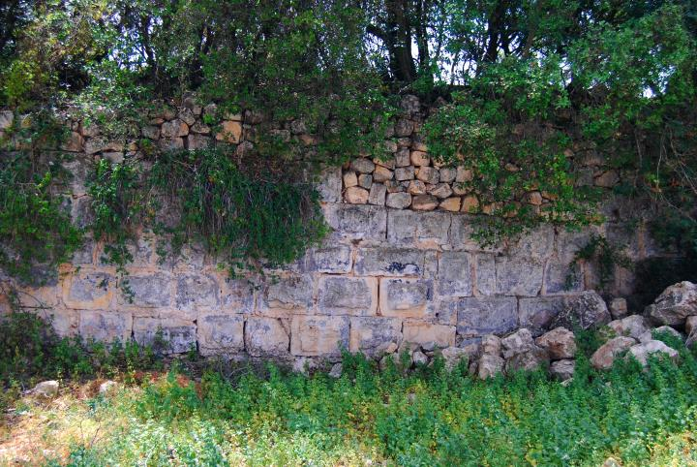

Fig.108 Crusader/Ayyubid fortification around the Monasteries, looking south

The Crusader period
We know from William of Tyre that Tancred, as soon as he was nominated prince of the Galilee, rushed to restore the churches of Nazareth, Tiberias and Tabor, with rich endowments. In 1102 Saewulf noted that on top of the mountain there " still remained three ancient monasteries, one in honor of our Lord Jesus Christ, another in honor of Moses and a third, a little further away, in honor of Elijah".
The scholars ask whether Tancred founded an abbey and entrusted it to the Benedictines, or did he restore an already existing abbey. In other words, they ask whether the religious who occupied Tabor at the beginning of the First Crusade were all Benedictines or did they even belong to an eastern order. A document of 1101 seems to support the first hypothesis: in this case it says that Tancred asked the Abbot Gerard of the Church of the Holy Savior on Mt. Tabor when the abbey had taken possession in the past, quae antiquitus possederat. With all probability the possessions of the Benedictines had been confiscated after the Crusade of Zimisce. It is a fact that in 1101 the Benedictines were on Tabor. Another question that the scholars have tried to answer is on the time when the Benedictines of Tabor had accepted the Rule of Cluny. Some hold it was before 1101; others think it was in 1130. These authors of the latter opinion base themselves on the information in a letter sent by Peter the Venerable, elected the ninth abbot of Cluny, in 1122, to the abbot of Tabor, also with the name of Peter, in which the writer is happy to have learned from a pilgrim brother that the community of the mountain was living according to Cluny's rules (PL 189, 266). On the other hand a manuscript of the 15th c., preserved at one time in the convent of Ara Coeli in Rome, affirmed that the monks killed in 1113 were German Cluniacs.
Baldwin I approved the donations of Tancred and in 1107 he added others in favor of the abbey "on the holy mountain". The lands of the Benedictines were truly notable: 34 villages (some of which were actual property, others were promised property) in the Lower Galilee, especially in the lands around the mountain, and 22 villages in the Jordan valley or beyond the Jordan. The tithes due to the abbey involved not only harvests and livestock, but also military service.
In the meantime (1103) the pope Paschal II had conferred on the abbot Gerard and his successors the title of archbishop of all of Galilee and of Tiberias with the right to wear the pallium and to use the lead seal. Moreover, Paschal II had placed the monastery and all its goods under the direct protection of the Holy See.
In the beginning then, when the dioceses of Nazareth and Tiberias were not yet founded, the abbot of Tabor had the episcopal jurisdiction over the Galilee. Around 1107-1109 the ancient metropolitan see of Beth Shean was transferred to Nazareth. This fact provoked a difficulty between the abbot Gerard and the bishop Bernard on the clarification of their jurisdictions. In 1112 the dispute was resolved in favor of Nazareth by Gibelinus, a bishop sent by the Holy See, with the consent of the clergy and the King Baldwin I. The abbot maintained the title of archbishop and the right to the pallium and to the seal but the abbey did not receive all the tithes from the villages any longer. A phrase from William of Tyre seems to indicate some unpleasant events. After recalling the donations made by Tancred to the churches of Nazareth, Tiberias and Tabor, the historian adds that these holy places lost no small part of their revenue due to the fraud and calumnies of later princes.
The buildings of this period are described by Daniel: "On the highest point, on the eastern side, there is an elevation, like a small mound of stones that end in a form of a cone: that is the place of the Transfiguration. There one sees a beautiful church dedicated to the Transfiguration and another, beside it, to the north of the first one, dedicated to Moses and Elijah. The place of the Transfiguration is surrounded by heavy stone walls with iron gates. It was at one time the seat of a bishopric and now it is a Latin monastery".
In 1113 during the Turk counter-crusade, Malduc Atabeg from Mossul invaded the Galilee. Baldwin I ordered the barons to come together immediately but he did not wait for them and alone with his forces he challenged Malduc at Tiberias. The Turks pushed towards Tabor and, in turn, beat the Crusaders before returning to their homeland. The Turks massacred all those they found in the abbey: 72 persons, between monks, servants and refugees. The martyrology of the Benedictine Gabriel Bucelinus (17th c.) remembers the victims on May 4; their remains were never found.
The Benedictines soon re-established themselves on the mountain. In 1115 the name of the abbot Raymond appears on a document of donation by the Count Riccardo of Calabria, who gave various possessions in the West to the community of the Holy Savior on Mt Tabor. To protect themselves from new attacks, the Benedictines fortified their monastery and installed a garrison of Turkopols.
The life of the religious on the mountain continued in peace for some years. In 1120 the abbot Peter participated in the Council of Nablus; in 1146 Pope Eugene III confirmed to the abbot Pontius and his successors the privileges granted by Paschal II. In 1169 the abbot Bernard I was named bishop of Lydda. A document from 1175 was signed by twelve monks who, according to Gariador, were probably the Benedictine community on Tabor at that time.
When Phocas visited the holy mountain in 1177 there were two Latin monasteries and one Greek monastery. One of the Latin groups occupied the very top, where the Lord was transfigured, and had many monks. The place of the Transfiguration was surrounded by a metal barrier and the very place where the Lord stood was marked by a round stone of extraordinary whiteness, marked with a cross.
In the second half of the 12th c. again one finds references to Tabor. John the Deacon, a canon of the Lateran, listed among the various relics kept at the lateran in the church of St Lawrence, lapis in quo Dominus transfiguratus est in monte, the stone on which the Lord was transfigured on the mountain (PL 78, 1390) (Grisar 1906) .
An invasion by Saladin destroyed the peace and was the beginning of the end. In 1183 while the Crusaders laid siege to Ain Jalud, Saladin sent troops to ransack the countryside. A band ascended Tabor and devastated the Greek monastery. William of Tyre, who refers to these events, gives us the name of the monastery: St Elijah. The Greeks fled and one hears of them again, we believe, in 1737. The Saracens also attacked the Benedictine abbey. Their fortifications, the Turkopols, and the courage of the monks, of their servants and of the refugees saved both the monastery and the church.
The Benedictines knew they had to think about the future. After this incident, the abbot Bernard II of Tabor and the abbot Fulk of St Paul of Antioch, with the consent of their confreres, signed an agreement by which the two communities agreed to grant hospitality to each other in case of expulsion.
They proved to be right. Only four years later Saladin attacked the Crusaders again and defeated them at the Horns of Hattin. His troops again climbed Tabor and this time finished the work they started on their previous sally. The Benedictines abandoned the mountain. We do not know whether some of them went to Antioch. It is certain that the abbot and a part of the community retreated to Acre to a property of the abbey, most probably the church of the Holy Savior (Rey 1868).
In 1204 the Crusaders signed a truce with the Sultan el-Adel, the brother to Saladin. As soon as it was done, el-Adel began to build a powerful fortress on Tabor. The exact date is noted in one of the Arab inscriptions found in the ruins: 5 du l-hiddsha 609, May 20, 1212 (Van Berchem 1903). The work was continued by Muazzam Isa, the son of el-Adel, who governed with his father. The church of the Transfiguration and the Benedictine abbey disappeared almost completely under the Saracen constructions.
The fortress with its massive walls and numerous towers was a masterpiece of military architecture at that time. It dominated the surrounding territory like an eagle ready to pounce on its prey. It stopped the Crusaders from reconquering Galilee and closed the road to Jerusalem to them (Bagatti 1975). Well-protected by a deep trench, the fortress extended a tentacle towards the east. Next to the ancient hermitage, they built a guardpost. The Franks, well aware of their limits, did not react.
However Pope Innocent III did react and in 1213 sent a solemn message to all of Christendom: the Saracens have constructed on Mt Tabor, in the very place where Christ manifested himself in his glory, a fortress determined to finish all Christian influence in the Holy Land. It threatens the city of Acre and by means of it the Saracens hope to destroy what remains of the kingdom of Jerusalem, because that unhappy endeavor lacks money and men. At the opening of the IV Lateran Council on Nov. 11,1215 Innocent III therefore announced his firm decision to begin a new Crusade. Perhaps he hoped to lead it himself but a few months later he died (July 16,1216).
The decision of Innocent III was confirmed by Honorius III. So the fifth Crusade was organized under the command of Andrew II of Hungary, and included many German, Flemish and Scandinavian princes. Andrew had made a vow to take up the cross on the request of his dying father but he did not show much enthusiasm for the task. Urged on by the Pope he finally left in August 1217 and arrived in Acre a little after Leopold VI duke of Austria who was the first to sail.
In Acre the new Crusaders were joined by John of Brienne king of Jerusalem, Hugo I of Lusignan king of Cyprus, the Templars and the Knights of St John. Their war council in a meeting at the end of October 1217 decided to attack the fortress. After they had stationed their numerous forces in the valley of Esdraelon and had made el-Adel move back, the Crusaders moved on to Tabor at the end of November and camped sur le ruissel du Cresson, one of the springs of the Wadi el-Bireh. In order to try and take the fortress they had to climb the mountain every day. Success seemed very unlikely because the thick woods impeded the movement of their war machines. At the beginning of December, thanks to a thick fog, the Crusaders arrived unseen by the besieged at the very gate of the city, so close that they could touch the walls with their javelins.
In spite of the brave conduct of John of Brienne, they were thrust back by a surprise sally of the beseiged Saracens. Some days later they made a final attempt: the whole army ascended and carried a huge ladder that leaned on the walls. The Saracens launched Greek fire against it, burnt it and inflicted great losses on the attackers. The Franks were demoralized and returned to Acre, not knowing that the enemy had been at the point of giving in. According to some authors, the seige lasted seven days; others say, seventeen days. Andrew II, who did not participate in the attack due to sickness, decided to go home. The Crusade had poor results but, at any rate, the threat had been useful.
Melek el-Adel, understanding that his "blessed" fortress (as the Arab inscriptions called it) was an arrogant provocation, decided to demolish it in 1218. On his side, Muazzam had so little hope in the final victory that he ordered demolished also the fortresses of Tibnin, Paneas, and later Safed, for fear they might fall into the hands of the Franks. The Franks however were in dire straits. The abbot Andrew of Mt Tabor together with the highest Latin prelates signed in Acre on October 1, 1220 a letter addressed to Philip II Augustus king of France, which spoke of the tragic conditions in the Holy Land and asked for help for John the king of Jerusalem, who was in great misery. In spite of everything, the properties which the abbey held would not be confiscated and a community of religious established themselves there a short while after the demolition of the fortress.
The Arab geographer Yakut, who wrote in 1225, says that on the top of Tabor there was a large church of solid construction and that to the south on that level one found the Deir et - Tajalla, the convent of the Transfiguration. Here in fact, Yakut notes, "it is said that Jesus---peace be upon him---was transfigured in the presence of his disciples".
Concerning the religious, according to Boniface of Ragusa, it was the kings of Hungary who sent to Tabor a good number of Hungarian monks of the order of St. Paul the first hermit. Perhaps, Meistermann thought, it had been King Andrew II who sent them to repair in some way the attack suffered, and perhaps those religious presided at the place with the permission and under the jurisdiction of the Benedictines.
During the Sixth Crusade, in 1229 Frederick II and Melek el-Kamel signed a truce that lasted ten years, thanks to which the Crusader kingdom was almost completely restored. Some people maintain that it was Frederick II who reconstructed a Latin church on Tabor and gave it to the Hungarian monks. The truce held for another five years and was finished with the invasion of the Khuwarizm Turks.
Louis IX of France, after the disastrous battles in Egypt, which cost the lives of half of the men on the Seventh Crusade, spent four years at Acre (May 13, 1250-April 24, 1254) and, by diplomacy, managed to keep the peace. Accompanied by his wife, the very brave Queen Margaret, the saintly monarch climbed Tabor on pilgrimage in 1251 for the vigil of the Annunciation. On April 1, 1255 Pope Alexander IV sent a bull to the Grand Master William of Castronove and the brothers of the Order of St. John. In essence he said: Your merits lead me to concede your request. In your petition you report to us that the monastery on Tabor has been destroyed by the enemies of Christ and one cannot expect that the abbot and monks would be able to restore it. Since it is very probable that the Saracens will erect fortifications there, you have asked us to intervene. Therefore, knowing well that you fight incessantly with all your strength against Christ's enemies, we concede to you the above-mentioned monastery with all its possessions, rights and tithes.
After the concession these clauses appear in the document: if peace or a truce continues between the Saracens and the Christians, you will build a fortress within ten years after you have taken possession of the mountain and you will keep forty knights in arms continually to defend Christian honor. To the Benedictine abbot and surviving monks, you will give the necessities of life, according to the judgment of the archbishop of Tyre and of the Abbot of Holy Mary of the Valley of Josaphat, who lives in Acre. To obtain the concession the Hospitalers sent 1,100 byzantine coins. During the following two years, upon the request of the Grand Master of the Order, Alexander IV sent other bulls in substitution for those of Paschal II and Eugene III, long since ineffectual due to the change in circumstances, and the Pope confirmed for the abbot of Tabor the title of archbishop with the right to wear the pallium.
Some of the Benedictines were happy with the decision. About a year after the transfer of the property, the monks Garino, Michael and Peter wrote to the Pope thanking him because the Hospitalers had been able to fortify the place. Other Benedictines raised some difficulties and in 1257 Alexander IV ordered the abbot of Holy Mary of the valley of Josaphat to help the Hospitalers obtain the goods and privileges attached to the convent on Tabor, if need be, by using the threat of excommunication.
The Knights of St John remained in command on Tabor for only eight years and later had to abandon it due to their behavior.
At the beginning of 1263 Baibars Bundukdari attacked the Franks. John of Ibelin, count of Jaffa, and Balian of Ibelin, count of Arsuf, resigned themselves to accept the conditions of the Mameluke sultan, one of which involved the exchange of prisoners. On April 8, the representatives of the government of Acre went to negotiate with Baibars in his camp on Tabor. The Templars and the Hospitalers refused to send back their prisoners so as not to lose their slave labor. Baibars himself got angry at their answer and broke off the negotiations. The Franks lost, besides Tabor, also Jaffa, Arsuf, Cesarea and Safed.
On August 20, 1263 Pope Urban IV sent a letter entitled VOCEM TERRORIS (The Voice of Terror) to St Louis IX, in which he denounced all the destruction wrought by Baibars at Nazareth, Capharnaum, Tabor and in all the Christian settlements up to the gates of Acre "et in tota Christianorum terra usque ad portas Acconis" (and in all the lands of the christians up to the gates of Acre). Louis for the second time took up the Crusade in 1267 but his death impeded his arrival on the holy mountain . The eighth and last crusade had no results whatsoever (Eubel 1913). The summit of Tabor was only a sea of rocks on which there rose up like a small petrified wave the ruins that had been venerated for hundreds of years. In the middle of the 17th c., even this wave was leveled.
The Post-Crusader period
On the other hand, Tabor was not forgotten: the tradition of the gospel incident continued to attract the pilgrims. In the section "the Cult on Tabor" we reported the chronicles relevant to the devotions; now we will give general information on the surviving ruins.
Burchard, who climbed Tabor twenty years after Baibars, saw the ruins of three tabernacles or cloisters, palaces, towers and buildings that had become shelters for wild beasts. Ricoldo of Monte Croce in 1294 read the gospel and wept over such desolation.
Some visitors, trusting in inexperienced guides or gathering ancient beliefs that had become so fantastic as to be unrecognizable, placed the most disparate events on Tabor.
Maundeville and Boldensel (cf ELS--518). in the Holy Land in 1322 and 1332 respectively, both speak of the school of the Lord, the Schola Domini, where Jesus taught his disciples the secrets of heaven. The Grotto of the Teachings, also called the grotto of the Our Father, is found on the Mt of Olives. Maundeville adds:
"On that mount and on the place of the Transfiguration, on the day of judgment, four angels will sound their trumpets and will raise up to new life all the people who have died since the creation. And they will come in body and soul to the judgment in the presence of the face of God , in the Valley of Josaphat. And it will be on Easter day, the day of the Resurrection of our Lord." The spaniard Oliver (1464) saw from the Mt of Olives "the road to Mt Tabor which is the place where Adam was created and where Abraham and Sarah are buried" (Oliver 1900).
Von Harff, at the end of the 15th c., also says: "The Christians who live in the region and are Syrians, Jacobites, Georgians, Abyssinians and others, maintain that Adam the first man disobeyed God on this Mt Tabor and that at the end of time four angels will announce the day of judgment from this mountain top.
The first pilgrim to give some solid information about the ruins was Niccol´o of Poggibonsi in 1345. Sources contemporary to the constructions which have come down to us unfortunately do not describe the structures or the decorations. The recent finds of archaeology are based only on the foundations and floors that remain. The pilgrim chronicles that mention the buidlings have a special importance inasmuch as they put us in contact with the reality and vicissitudes of the past.
We read in Poggibonsi: "This mountain is very high and large, and almost round; and on top there is a flat surface, which once was a farmland but now is a wasteland; and in the middle there is a church, and, in the middle of said church, there is a tomb (round-shaped), elevated inside the whole building. And there, our Lord Jesus Christ, wanting to show his glory to his apostles, there where the tomb is, he was transfigured, and appeared suddenly with Moses and Elijah, and they spoke with him; and the voice was heard from heaven, and thus was written in golden letters on the said tomb, and they read thus: Hic est filius meus dilectus, in quo mihi bene complacui, ipsum audite (This is my beloved Son, in whom I am well-pleased, hear him). And on the earth there are forms, like the confused St Peter, St James and St John, fallen on the ground before the divine glory; and where St Peter fell, there is the inscription: Domine, bonum est nobis hic esse, etc. (Lord, it is good for us to be here). The church is almost destroyed except for the tomb." There remained the crypt then, with paintings and relevant graffiti on a wall and on the floor, whereas the upper part of the edifice was destroyed.
The ruins of the buildings still survived for a century and a half. In 1485 Suriano adds some architectural detail: "On Zebel Tubar [...} a church was built with three tribunes, with three tents pitched together. And where Christ was transfigured there was a stairway of fine marble, of eight steps, four yards wide, and at the top of this staircase there was a stone placed to serve as an altar.
What so many past pilgrims had experienced here and elsewhere also happened to Suriano:"And once the Mass was over, we were attacked by thieves who were hidden in those carob trees, because they had seen the new chalice and chasuble of chremisin damascus material. Tamen (Latin for however), it was not a disaster because we were well-accompanied: but we did eat bread and salt together."
Sixty-seven years passed by without any important information and then Boniface of Ragusa (1552) wrote: "On the summit of the mountan [...] there is a church with three chapels. On the spot where the Christ was seen in glory there is the largest chapel, with a chapel on the right to Moses and another on the left to Elijah [...} In the main chapel, by the grace of God, there is kept a statue of the Transfigured Savior [...] which is very elegant. Moses, the bearer of the Law, is painted on the right wall and Elijah on the left. Zuallart explains why the rigors of the climate did not complete the destruction begun by Baibars: "Nothing else remains except the three chapels which the infidel occupy, and as mosques they keep a roof to preserve them from the rain and rough weather." But while the roof protected the walls, the infidel had ruined the "very ancient paintings" of the central chapel. Zuallart saw only the remains. He wrote in 1586; Castela, who sixteen years later visited Tabor confirms the change of the three chapels into mosques (Castela 1603). Levaillant noted also the edgings of the decorations left in 1613 (Levaillant ). The Roman traveler Della Valle in 1616 found: "many ruins of a great church and a monastery, for as I imagine, they were constructed in the place, where our Lord was transfigured ", and he was surprised by the hay cultivated on top of the mountain. "But I saw later, that the mountain was inhabited on top; and that among the ruins of the ancient churches, there lived some few, very poor families, segregated from the rest of the world, some of which did the planting, which I certainly had compassion to see them in such a place; especially the half-nude young women and the little 4-5 year old children, whom I saw running among the trees, like wild cats." Della Valle is the only chronicler who, as far as we know, mentions a permanent settlement on the mountain.
The situation worsened in the immediately following years. Quaresmi, in his monumental work on the Holy Land (1626), dedicates only a few lines to Tabor:" Currently almost everything has been destroyed: one sees many ruins of buildings and gates in the walls; from these it is easy to conclude that there used to be a strong fortress and other noble buildings. On the summit, on the side, besides the foundations of the buildings, one sees some underground rooms."

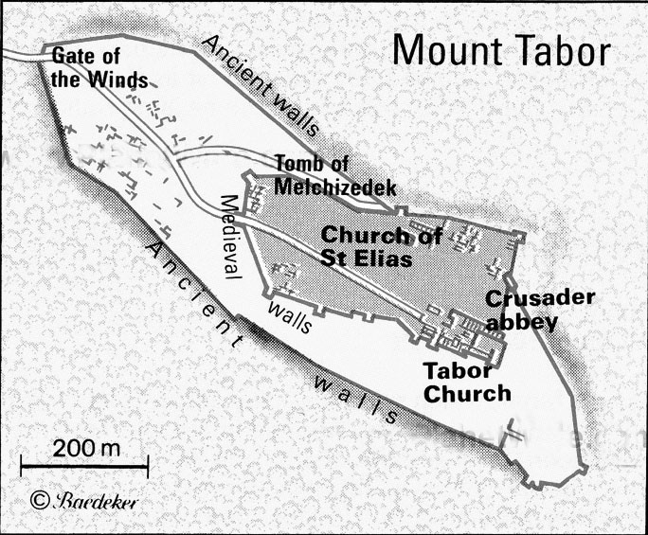
Fig.109 Mt. Tabor, General map of the mountain summit

